SOC Analyst Project
Network Security Monitoring through Firewall Log Analysis

Project Overview
This project focuses on firewall log analysis and security monitoring to simulate real-world SOC Level-1 operations. It involves analyzing enterprise firewall logs, identifying suspicious network activities, classifying security events, and following SOC workflows such as alert triage and escalation.
The project demonstrates practical knowledge of network security monitoring, threat detection, and log-based investigation using enterprise firewall technologies.

Key Skills Demonstrated
Firewall Log Analysis (Fortinet & Palo Alto)
• SOC Level-1 Monitoring & Triage
• Incident Identification and Risk Categorization
• Security Dashboard Design & Visualization
• Network Traffic Analysis (TCP/IP, Ports, Protocols)
• Policy & Rule Analysis
• Alerting and Escalation Understanding
• Security Documentation & Reporting

Tools & Technologies
- Fortinet (FortiGate Firewall Logs)
- Palo Alto Firewall Logs
- SIEM / Log Analysis Platform
- Security Dashboards & Visualizations
- TCP/IP Networking & Firewall Concepts
- Windows & Linux Operating Systems

Prepared By
Swarupananda Das
Aspiring SOC Analyst | Cybersecurity Enthusiast

INDEXING

Project Objective
The objective of this project is to perform structured analysis of firewall logs generated by Fortinet and Palo Alto Networks firewalls in order to identify security events, understand traffic behavior, and detect potential threats within a network environment.
This project aims to simulate real-world SOC Analyst (Level 1) activities related to log monitoring, investigation, and security event interpretation.
Primary Objective
The primary objective of this project is to analyze and interpret firewall logs from Fortinet and Palo Alto firewalls to detect suspicious activities, policy violations, and potential security incidents by examining key log attributes such as traffic action, source and destination details, application, protocol, and severity.
Detailed Objectives
To understand the log structure and fields of Fortinet and Palo Alto firewall logs
• To analyze allowed, denied, and dropped traffic events
• To identify suspicious patterns such as unauthorized access attempts, port scanning, and abnormal traffic behavior
• To differentiate between internal and external network traffic
• To evaluate firewall actions (allow, deny, drop, reset) and their security implications
• To correlate log events with potential threat scenarios
• To improve hands-on skills in firewall log monitoring and SOC-level analysis
• To prepare actionable findings that support incident detection and escalation
Outcome of the Project
By completing this project:
- Gained practical experience in analyzing enterprise-grade firewall logs
- Developed a clear understanding of how Fortinet and Palo Alto firewalls record and classify network traffic
- Improved ability to detect and interpret suspicious or malicious activities using firewall data
- Strengthened SOC Level 1 skills related to monitoring, investigation, and reporting
- Built confidence in handling real-world security logs used in Security Operations Centers.
- Created a strong project portfolio suitable for SOC Analyst, Security Analyst, and Blue Team roles

Tools & Technologies Used
Firewall Platforms
- Fortinet Firewall (FortiGate)
Used for analyzing firewall traffic logs, including allowed and blocked connections, policy enforcement actions, and security event classification.
- Palo Alto Networks Firewall
Used to examine detailed traffic logs, application-based filtering, threat detection events, and security rule enforcement.

Log Analysis & Monitoring Tools
- SIEM / Log Analysis Platform
Used to ingest, filter, and analyze firewall logs for identifying suspicious activities and security events.
- Dashboard & Visualization Tools
Used to create visual representations of firewall events, traffic trends, top source/destination IPs, and action-based statistics.
Operating Systems
- Windows OS
Used for log analysis, reporting, and dashboard visualization.
- Linux OS
Used for understanding log formats, basic command-line analysis, and handling log files.
Networking & Security Concepts
- TCP/IP, UDP, ICMP Protocols
- Port Numbers and Services
- Firewall Rules and Access Control Policies
- Internal vs External IP Address Identification
- Threat Severity and Event Classification

Analytical Skills & Techniques
- Log Parsing and Event Correlation
- Pattern Recognition for Suspicious Traffic
- Traffic Flow Analysis
- Incident Identification and Basic Escalation Understanding

Documentation & Reporting Tools
- Microsoft Word / Google Docs – for project documentation
- Microsoft Excel – for log filtering, sorting, and analysis
- PDF Tools – for final report sharing

Network & Security Architecture Overview
The network and security architecture for this project is designed to simulate a real-world enterprise environment where firewall devices play a critical role in traffic inspection, access control, and threat prevention. The architecture focuses on defensive security monitoring and log-based analysis, aligned with SOC Analyst (Level 1) responsibilities.
Architecture Design Overview
The architecture consists of the following core components:
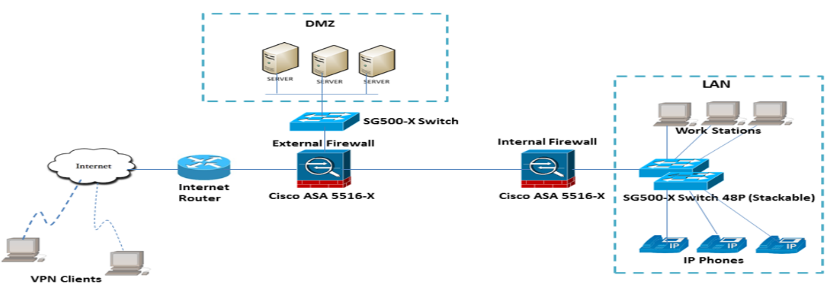
- Internal Network Zone
Represents trusted internal users, endpoints, and servers generating outbound and inbound network traffic.

- Firewall Security Layer
Enterprise-grade firewalls from Fortinet (FortiGate) and Palo Alto Networks act as the primary security control point.
These firewalls enforce security policies, inspect traffic, and generate detailed logs for each network session.

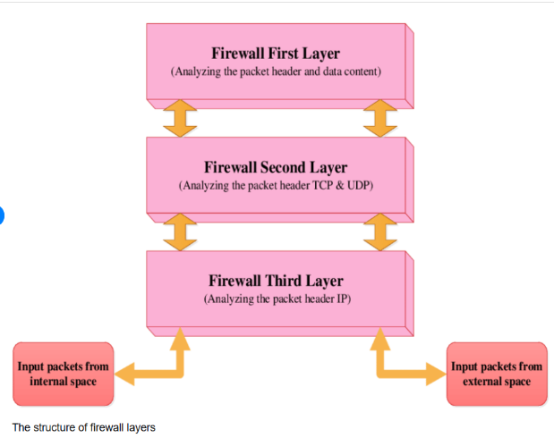

- External Network / Internet Zone
Represents untrusted external networks interacting with internal resources through the firewall.
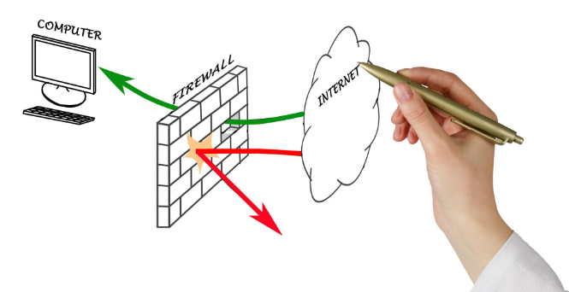

- Log Collection & Analysis Layer
Firewall logs are forwarded to a centralized log analysis or SIEM platform for monitoring, correlation, and investigation.
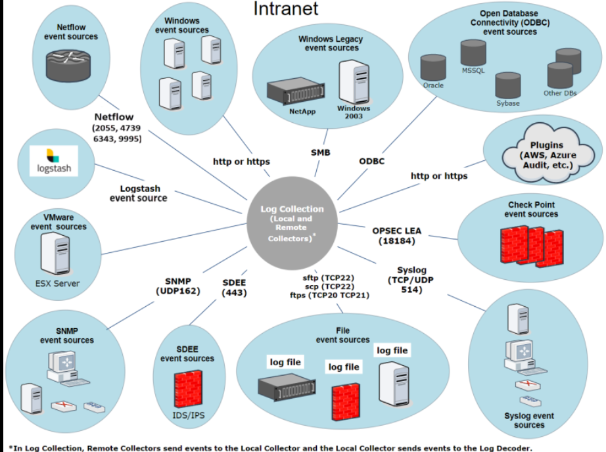

Traffic Flow & Security Controls
- All inbound and outbound traffic passes through the firewall
- Firewall rules determine whether traffic is allowed, denied, dropped, or reset
- Traffic inspection is performed based on:
  - Source and destination IP addresses
  - Ports and protocols
  - Application and service identification
  - Security policy and threat signatures
Each traffic decision generates a log entry that becomes the primary data source for analysis.

Logging & Monitoring Architecture
- Firewalls generate logs for:
  - Traffic events
  - Policy enforcement actions
  - Threat detection and security alerts
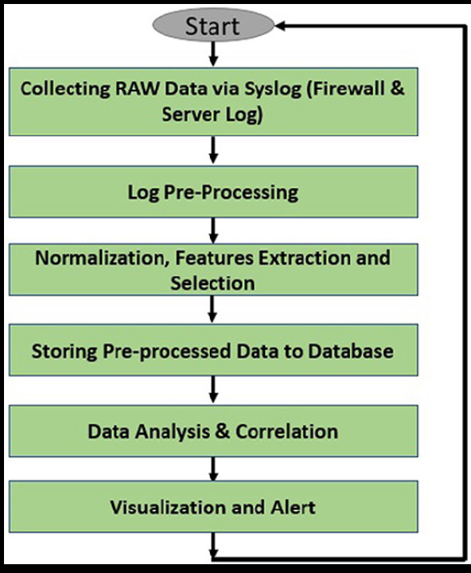

- Logs are centrally collected to enable:
  - Real-time monitoring
  - Historical analysis
  - Detection of suspicious or anomalous behavior
- Dashboards and queries are used to visualize:
  - Traffic trends
  - Top talkers (IP addresses)
  - Blocked vs allowed events
  - Severity-based security incidents
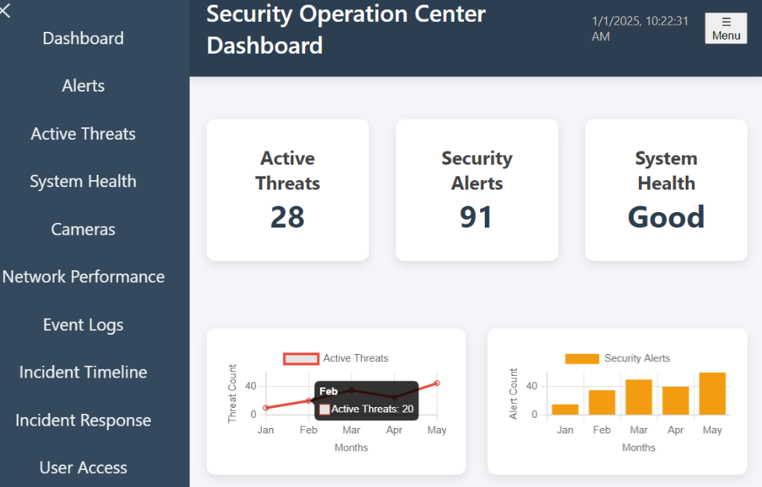

Log Sources & Log Types
Log Sources
The primary log sources for this project are enterprise firewall devices used for network security monitoring:
- Fortinet (FortiGate Firewall)
Generates detailed logs related to network traffic, policy enforcement, and security events.
- Palo Alto Networks Firewall
Produces rich, application-aware logs covering traffic sessions, security policy decisions, and threat-related activities.
These logs are collected and analyzed to gain visibility into network behavior and security incidents.

Log Types
The following log types were analyzed during the project:
- Traffic Logs
Record allowed, denied, and dropped network sessions including source, destination, ports, and protocols.
- Security / Threat Logs
Capture suspicious or malicious activities such as intrusion attempts, policy violations, and abnormal traffic behavior.
- Policy Enforcement Logs
Document firewall rule matching and access control decisions.
- System & Event Logs
Provide information related to firewall system operations, status changes, and administrative events.

Log Parameters Analyzed
The analysis focused on key firewall log fields that are critical for SOC monitoring and investigation:
- Timestamp – Date and time when the event occurred
- Source IP Address – Originating IP of the traffic
- Destination IP Address – Target IP of the traffic
- Source Port / Destination Port – Network ports involved in the session
- Protocol – TCP, UDP, ICMP, or other network protocols
- Action Taken – Allow, Deny, Drop, Reset
- Firewall Rule / Policy Name – Rule responsible for the action
- Application / Service – Identified application or service (where applicable)
- Severity Level – Risk or threat level associated with the event
- Direction of Traffic – Inbound or Outbound
- Bytes Sent / Received – Volume of data transferred
- Session Duration – Length of the network session

Fortinet & Palo Alto Raw Log Analysis
Raw firewall log analysis involves examining unprocessed, original log entries generated directly by firewall devices. These logs provide granular visibility into network traffic, security policy enforcement, and potential threat activities.
In this project, raw logs from Fortinet (FortiGate) and Palo Alto Networks firewalls were analyzed to simulate real-world SOC Level 1 monitoring and investigation tasks.

Fortinet (FortiGate) Raw Log Analysis
Log Characteristics
- Format: Key–value pairs (text-based)
- High-volume, real-time traffic logs
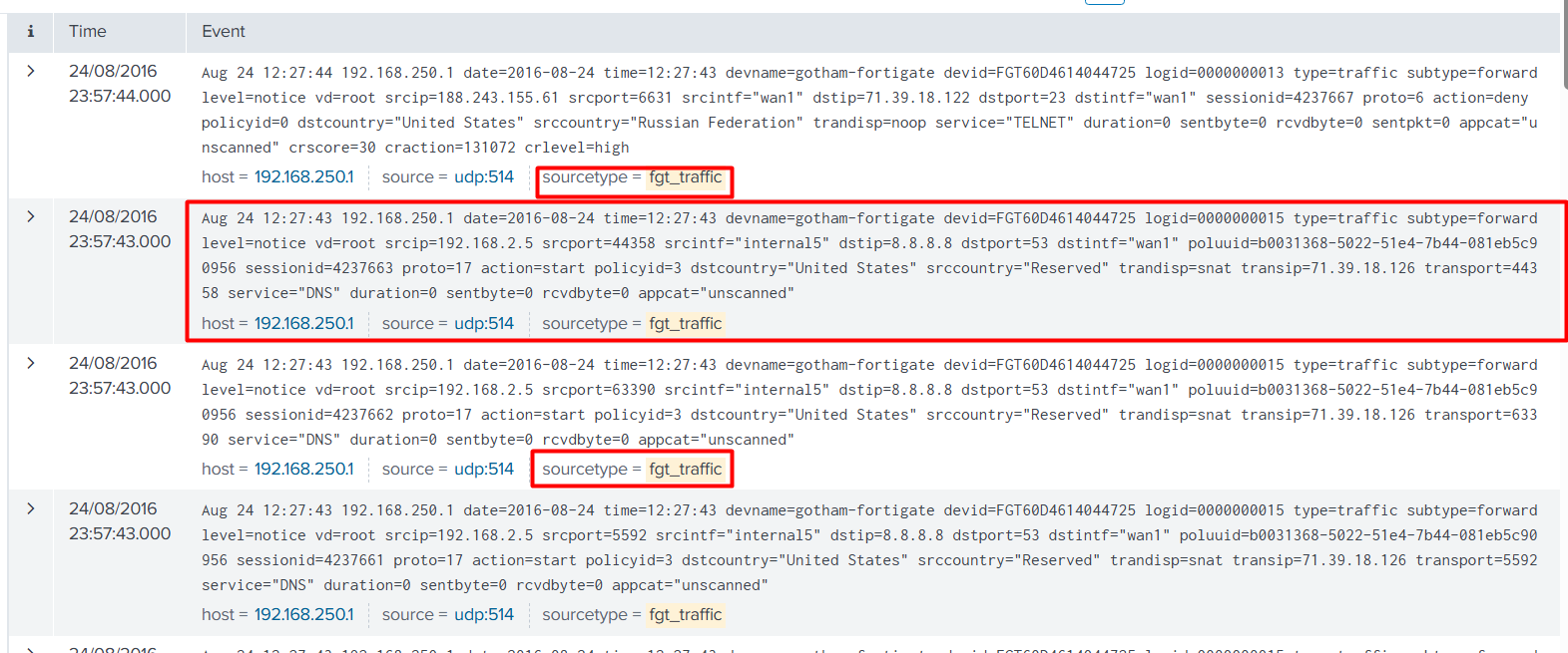
- Policy- and action-oriented logging
Key Fields Analyzed
- date / time – Event occurrence time
- srcip / dstip – Source and destination IP addresses
- srcport / dstport – Network ports
- proto – Protocol (TCP, UDP, ICMP)
- action – accept / deny / drop
- policyid / policyname – Firewall rule applied
- service – Service or port-based classification
- level – Severity level
- sentbyte / rcvdbyte – Data transfer size
Analysis Focus
- Identifying blocked vs allowed traffic
- Detecting repeated denied connections from same source IP
- Recognizing port scanning patterns
- Differentiating internal and external IP traffic
- Reviewing policy effectiveness and misconfigurations

Palo Alto Firewall Raw Log Analysis
Log Characteristics
- Structured, detailed, and application-aware logs
- Strong visibility into Layer 7 (application layer) traffic
- Rich metadata for threat detection
Analysis Focus
- Monitoring application-based traffic behavior
- Detecting suspicious or unauthorized applications
- Identifying abnormal session termination patterns
- Correlating deny/reset actions with potential threats
- Understanding policy enforcement at application level

Raw Log Analysis Methodology
The analysis was performed using the following steps:
- Collection of raw firewall logs
- Identification of critical security-related fields
- Filtering allowed vs denied traffic
- Detection of anomalies and suspicious patterns
- Correlation of repeated events and high-risk indicators
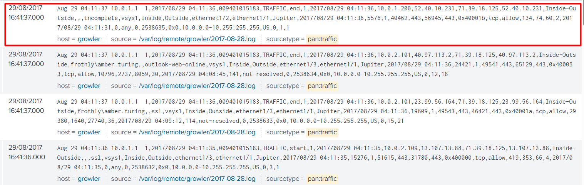
- Documentation of findings for SOC reporting
Key Fields Analyzed
- Receive Time – Log ingestion timestamp : 2017/08/29 04:11:36
- Source / Destination – IP addresses: src_ip 10.0.1.200 dst_ip 52.40.10.231
- Application – Identified application (App-ID): incomplete
- Protocol – TCP / UDP / ICMP: TCP
- Action – allow / deny / drop / reset : Allow
- Rule Name – Security policy matched: Inside-Outside
- Session End Reason – How the session terminated : end
- Bytes Sent / Received – Traffic volume: Sent: 134 Received: 74
Severity – Risk level of the event : Reason

Firewall Monitoring Posture Design
The firewall monitoring posture is designed to provide continuous visibility into network traffic, early detection of suspicious activity, and actionable insights for SOC analysts.
This dashboard represents a SOC Level 1 monitoring view, focusing on traffic behavior, blocked events, external threats, and policy enforcement.

1. Blocked Connections
Purpose:
To identify traffic that has been denied or dropped by the firewall.
Security Value:
- Detects unauthorized access attempts
- Highlights brute-force or scanning behavior
- Helps identify misconfigured rules or risky sources
SPL Command :
index="botsv2" sourcetype="pan:traffic" action IN (deny, drop, blocked)
| stats count by src_port, dest_port, src_ip, dest_ip
| sort - count
SOC Use Case:
Repeated blocked connections from the same IP may indicate reconnaissance or attack attempts.
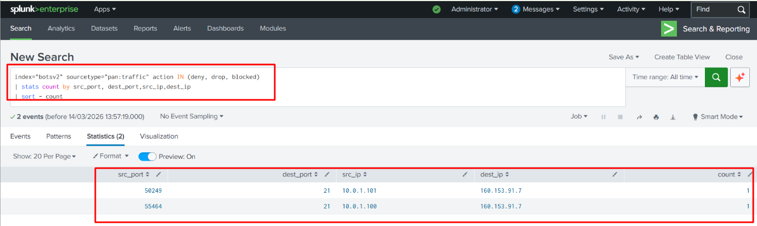
2. Allowed Connections
Purpose:
To monitor permitted traffic passing through the firewall.
Security Value:
- Ensures only legitimate traffic is allowed
- Helps detect suspicious traffic that bypasses security controls
- Supports policy validation
SPL Command :
index="botsv2" sourcetype="pan:traffic" action=allow
| stats count(action)
SOC Use Case:
Unexpected allowed traffic to sensitive ports can indicate policy gaps or insider threats.
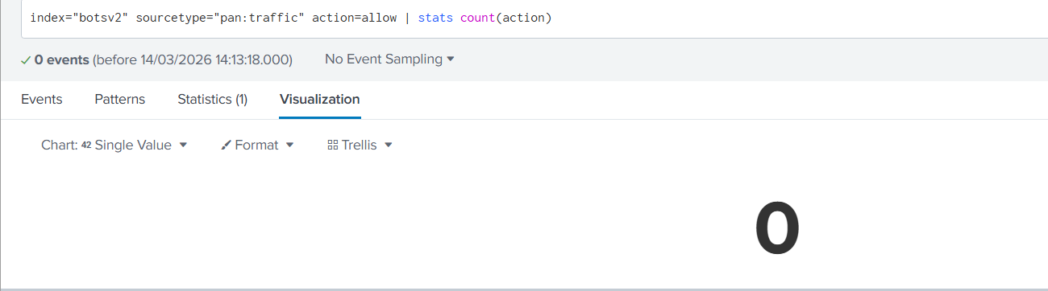
3. External Source IPs
Purpose:
To track traffic originating from external (untrusted) IP addresses.
Security Value:
- Identifies high-risk external sources
- Helps detect attacks originating from the internet
- Supports geo-based threat analysis
SPL Command :
index="botsv2" sourcetype="pan:traffic"
| where NOT cidrmatch("10.0.0.0/8", src_ip)
AND NOT cidrmatch("172.16.0.0/12", src_ip)
AND NOT cidrmatch("192.168.0.0/16", src_ip)
| stats count by src_ip, dest_ip, dest_port
| sort - count
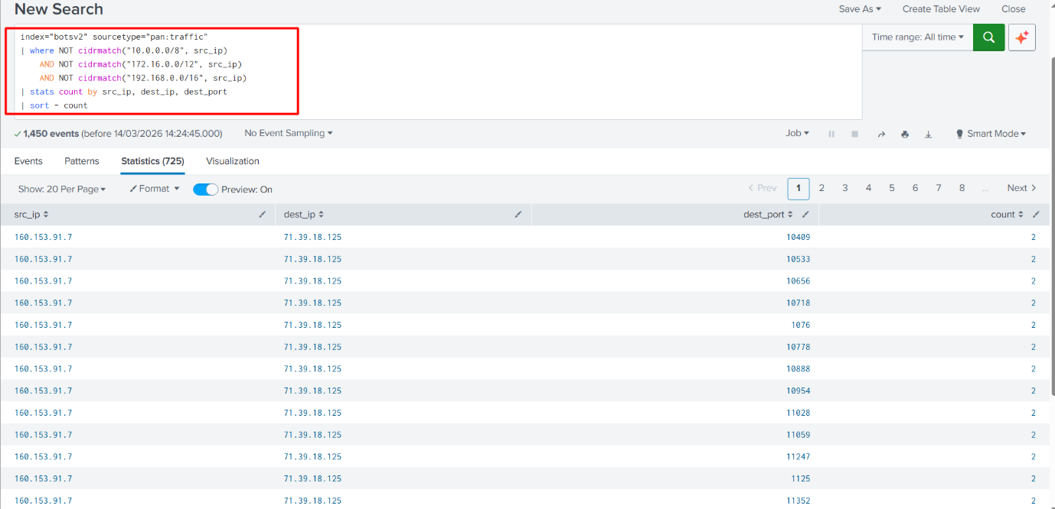
SOC Use Case:
Multiple attempts from unknown external IPs may indicate botnet or attacker infrastructure.

4. External Destination IPs
Purpose:
To monitor outbound connections from internal systems to external destinations.
Security Value:
- Detects suspicious outbound communication
- Helps identify Command-and-Control (C2) traffic
- Monitors data exfiltration attempts
SPL Command :
index="botsv2" sourcetype="pan:traffic"
| where NOT cidrmatch("10.0.0.0/8", dest_ip)
AND NOT cidrmatch("172.16.0.0/12", dest_ip)
AND NOT cidrmatch("192.168.0.0/16", dest_ip)
| stats count by src_ip, dest_ip, dest_port
| sort - count

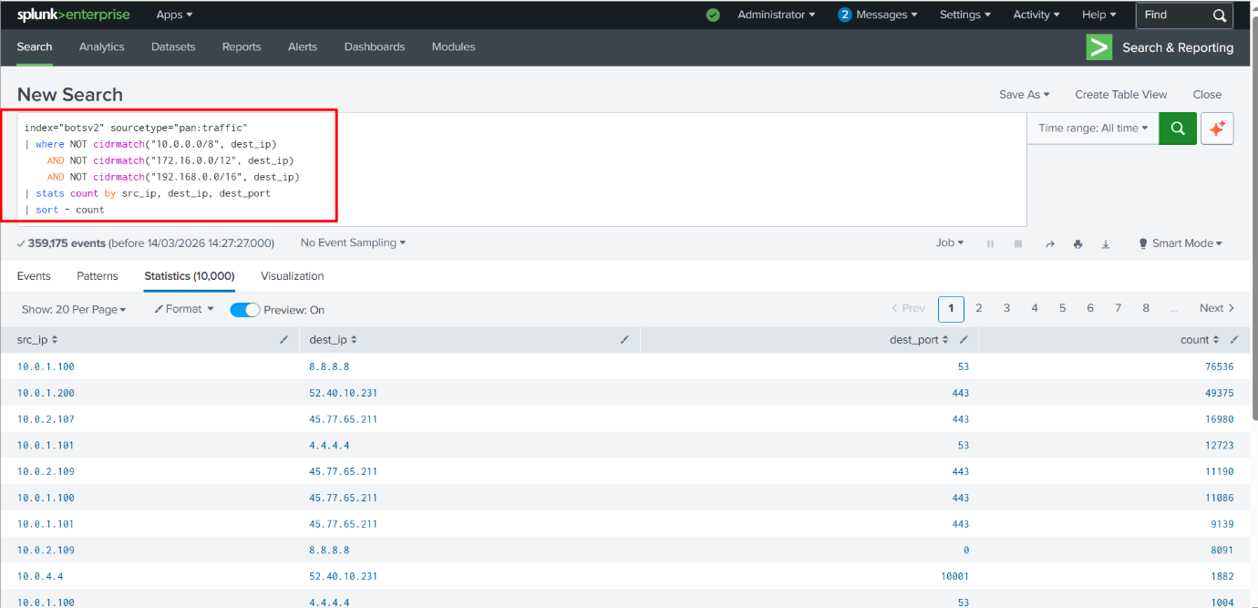
SOC Use Case:
Unexpected outbound traffic to rare IPs may indicate malware infection.
5. Network Traffic by Action (Logarithmic Scale)
Purpose:
To visualize traffic distribution based on firewall actions (Allow / Deny / Drop).
Security Value:
- Quickly highlights abnormal spikes
- Improves visibility in high-volume environments
- Helps detect attack surges
SPL Command :
index="botsv2" sourcetype="pan:traffic"
| timechart span=5m count by action
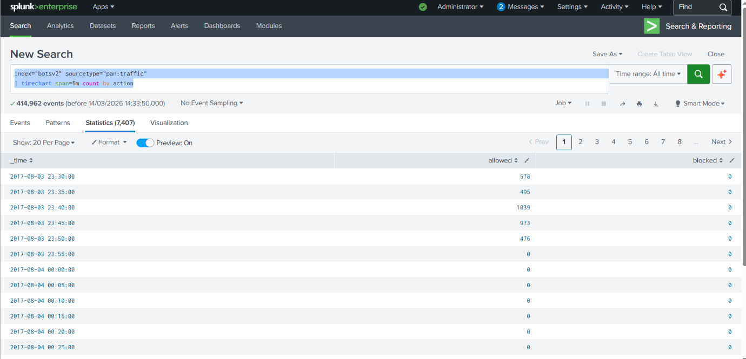
SOC Use Case:
Sudden increase in denied traffic may signal an ongoing attack
6. Traffic by Protocol
Purpose:
To analyze network traffic based on protocols (TCP, UDP, ICMP).
Security Value:
- Detects protocol abuse
- Identifies ICMP floods or UDP-based attacks
- Helps baseline normal traffic behavior
SPL Command :
index="botsv2" sourcetype="pan:traffic"
| timechart span=5m count by protocol
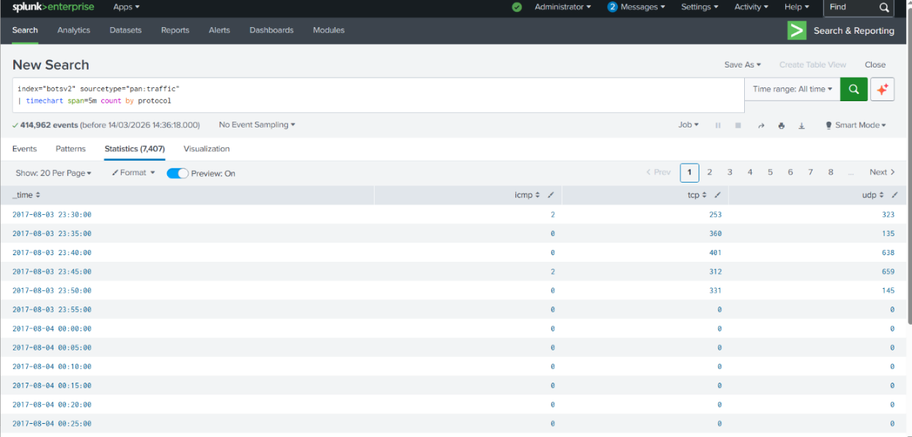
SOC Use Case:
Unusual ICMP traffic may indicate network reconnaissance.

7. Traffic by Application / Protocol
Purpose:
To identify applications generating network traffic.
Security Value:
- Detects unauthorized applications
- Helps enforce application-level policies
- Improves Layer 7 visibility (especially Palo Alto logs)
SPL Command :
index="botsv2" sourcetype="pan:traffic"
| timechart span=5m count by app
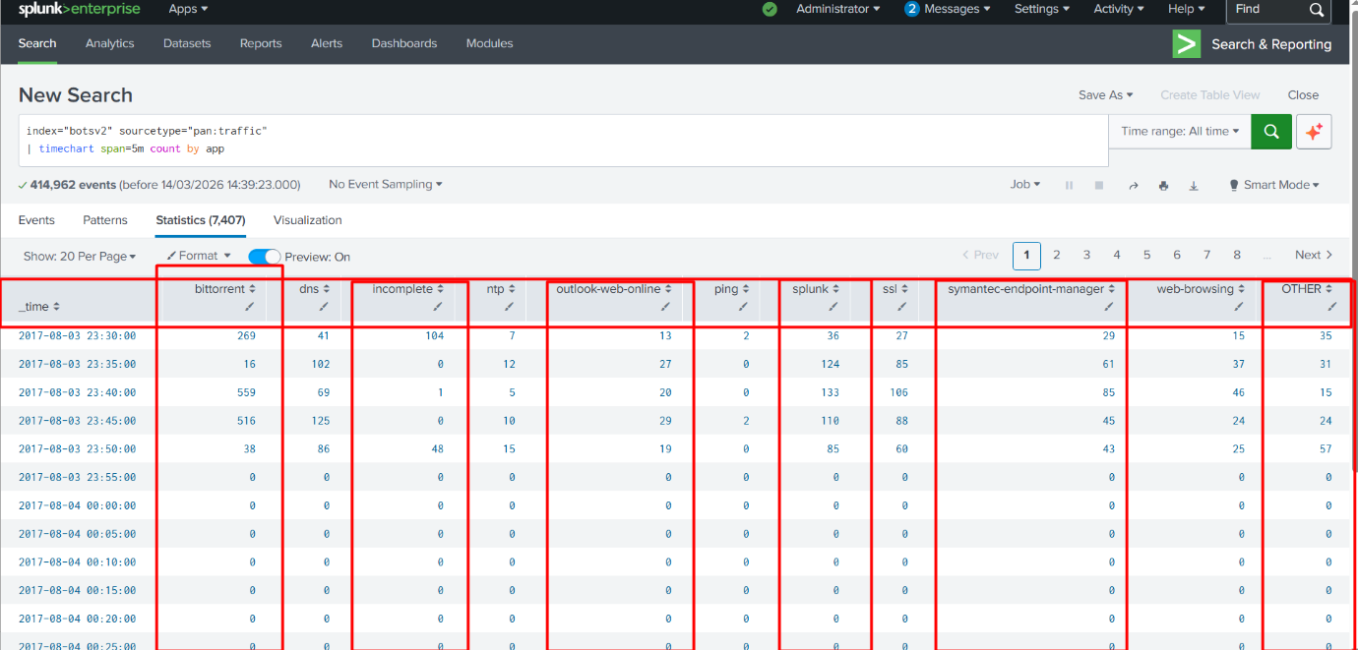
SOC Use Case:
Unexpected applications can indicate policy violations or malware activity.

8. Blocked Incoming Traffic by Destination Port
Purpose:
To identify which ports are most frequently targeted.
Security Value:
- Highlights commonly attacked services
- Detects port scanning behavior
- Supports firewall hardening
SPL Command :
index="botsv2" sourcetype="pan:traffic" action IN (deny, drop, blocked)
| stats count by src_ip, dest_ip, dest_port
| sort - count
SOC Use Case:
Repeated blocks on ports like 22, 3389, or 445 indicate brute-force attempts.
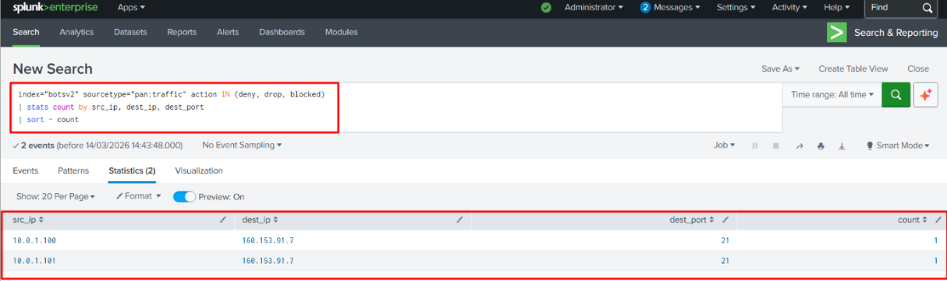

9. Incoming Traffic by Application / Protocol
Purpose:
To analyze incoming traffic patterns by application.
Security Value:
- Detects malicious or unnecessary services
- Improves inbound threat visibility
SPL Command :
index="botsv2" sourcetype="pan:traffic"
| table src dest app protocol
| head 20
SOC Use Case:
Unexpected inbound applications may indicate exposed services.
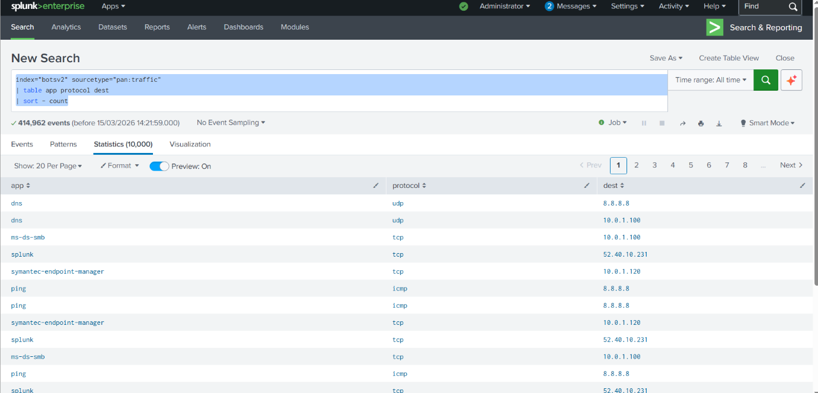
10. Top Countries by Blocked Connections
Purpose:
To identify geographic sources of blocked traffic.
Security Value:
- Supports geo-threat analysis
- Helps justify geo-blocking policies
SPL Command :
index="botsv2" sourcetype="pan:traffic" action=allowed
| iplocation src
| stats count by src Country
| sort - count
| head 10
SOC Use Case:
High traffic from certain regions may indicate targeted attack campaigns.
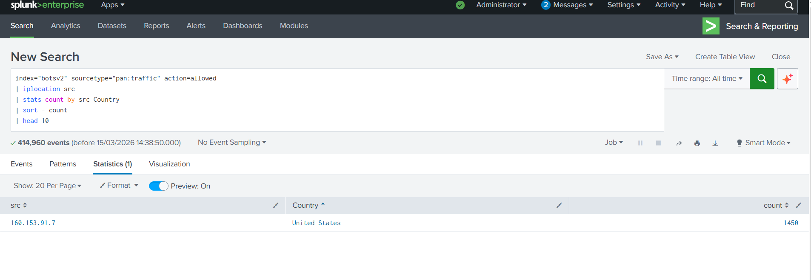
11. Top Sources by Blocked Connections
Purpose:
To identify the most aggressive source IPs.
Security Value:
- Pinpoints attackers
- Helps prioritize investigation and blocking
SPL Command :

SOC Use Case:
Single IP generating excessive blocks may require blacklisting or escalation.
12. Top Blocked Traffic Categories
Purpose:
To classify blocked traffic by category or type.
Security Value:
- Identifies attack trends
- Helps improve security policies
- 2Supports management reporting
SPL Command :
index="botsv2" sourcetype="pan:threat"
| stats count by category
| sort - count
| head 10
SOC Use Case:
High malware or scanning category blocks indicate active threat environment.
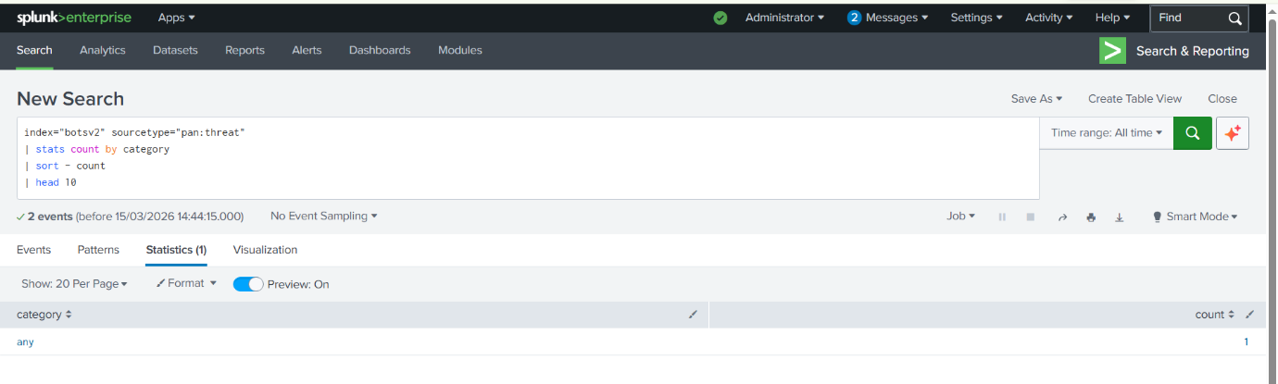

Security Dashboards & Visualizations
Security dashboards and visualizations were designed to provide real-time visibility into firewall activity, support continuous monitoring, and enable quick decision-making for SOC analysts.
The dashboards consolidate raw firewall logs into meaningful visual insights, allowing analysts to detect threats, monitor network behavior, and prioritize investigations efficiently.

Dashboard Design Objectives
- Centralized visibility of firewall events
- Quick identification of suspicious and malicious activity
- Reduction of alert fatigue through visual prioritization
- Support for SOC Level 1 monitoring and escalation workflows
- Transformation of raw logs into actionable intelligence

Key Dashboards & Visual Components
1. Blocked vs Allowed Connections Dashboard
- Visualizes firewall decisions on network traffic
- Helps identify spikes in blocked traffic indicating possible attacks
- Supports validation of firewall policy effectiveness
SOC Value: Early detection of unauthorized access attempts

2. External Source & Destination IP Dashboard
- Displays top external IPs interacting with the network
- Highlights risky inbound sources and suspicious outbound destinations
SOC Value: Detection of brute-force attempts, botnet activity, or C2 communication

4. Traffic by Protocol Dashboard
- Breaks down traffic by TCP, UDP, and ICMP
- Helps identify protocol misuse or abnormal patterns
SOC Value: Detection of protocol-based attacks such as ICMP floods
5. Traffic by Application / Protocol Dashboard
- Displays application-level visibility (especially relevant for Palo Alto logs)
- Identifies unauthorized or high-risk applications
SOC Value: Layer-7 traffic monitoring and policy enforcement
6. Blocked Incoming Traffic by Destination Port
- Highlights commonly targeted ports
- Identifies exposed or misconfigured services
SOC Value: Detection of port scanning and brute-force attacks
7. Geo-Location Based Dashboard
- Shows top countries generating blocked traffic
- Supports geographic threat analysis
SOC Value: Identification of region-based attack trends
8. Top Blocked Traffic Categories
- Categorizes blocked events based on traffic or threat type
- Helps understand overall attack patterns
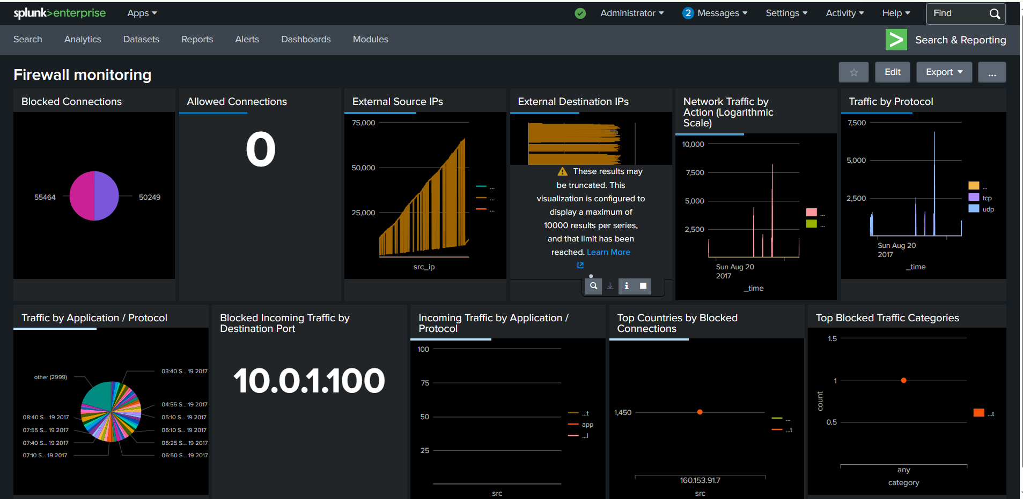
SOC Value: Strategic improvement of firewall policies
Alerting & Event Classification
Alerting and event classification are essential components of effective security monitoring. In this project, firewall events generated by Fortinet and Palo Alto Networks firewalls were analyzed and categorized to support timely detection and response by SOC analysts.

Alerting Strategy
Alerts were designed based on event severity, frequency, and behavior patterns rather than single log events to reduce false positives.
Alert Triggers Included:
- Multiple blocked connections from a single source IP within a short time window
- Repeated access attempts to sensitive or restricted ports
- Sudden spikes in denied or dropped traffic
- Suspicious outbound connections to unknown external IP addresses
- Policy violations involving unauthorized applications or services
SOC Benefit:
Enables early warning of potential attacks and prioritizes incidents requiring analyst attention.

Event Classification
Firewall events were classified into structured categories to simplify analysis and escalation.
Event Categories:
- Informational – Normal allowed traffic and expected behavior
- Low Severity – Minor policy violations or misconfigured traffic
- Medium Severity – Repeated denied attempts, abnormal access patterns
- High Severity – Possible brute-force attempts, port scans, or malware communication
Classification Criteria:
- Firewall action (allow, deny, drop)
- Source and destination reputation
- Port and protocol sensitivity
- Event frequency and pattern repetition
SOC Alignment:
This classification supports SOC Level 1 triage and determines whether escalation to higher SOC tiers is required.

Security Monitoring Limitations and Mitigation
1. High Volume of Firewall Logs
Limitation:
Large volumes of firewall logs can overwhelm analysts and obscure critical events.
Mitigation:
- Use of filters and thresholds
- Aggregation of repeated events
- Dashboard-based visualization for quick insights

2. False Positives
Limitation:
Legitimate traffic may trigger alerts due to strict firewall rules.
Mitigation:
- Alert tuning based on historical baselines
- Use of behavior-based alerting instead of single-event triggers
- Continuous rule refinement

3. Limited Context in Raw Logs
Limitation:
Firewall logs alone may lack full context about user identity or endpoint behavior.
Mitigation:
- Correlation with other log sources (endpoint, authentication, DNS)
- Enrichment using IP reputation and geo-location data

4. Delayed Detection of Advanced Threats
Limitation:
Sophisticated attacks may evade firewall detection by using allowed ports or encrypted traffic.
Mitigation:
- Application-level analysis (Palo Alto App-ID)
- Continuous monitoring of outbound traffic behavior
- Correlation with anomaly-based detection methods

5. Dependency on Proper Log Normalization
Limitation:
Incorrect field mapping or lack of CIM normalization can affect dashboard accuracy.
Mitigation:
- Proper log parsing and normalization
- Validation of log fields before alert creation
- Regular review of data models and field mappings

Overall Security Improvement
Despite these limitations, the implemented alerting and classification mechanisms significantly enhance:
- Threat visibility
- Incident prioritization
- Analyst efficiency
- SOC monitoring maturity

SOC Level-1 Analysis Workflow
The SOC Level-1 analysis workflow defines the first line of defense in security operations. In this project, the workflow is designed around firewall log analysis from Fortinet and Palo Alto Networks, focusing on continuous monitoring, rapid triage, and accurate escalation.

Incident Identification & Initial Triage
Incident Identification
Security incidents are identified through:
- Real-time firewall alerts
- Abnormal spikes in blocked or denied traffic
- Repeated access attempts from unknown or external IPs
- Suspicious outbound connections
Initial Triage
Once an event is detected, the analyst:
- Validates whether the event is a true security issue or a false positive
- Checks source/destination IP reputation
- Reviews event frequency and patterns
- Determines the affected assets
SOC Level-1 Responsibility:
Confirm the incident and decide whether escalation is required.

Threat Detection & Risk Categorization
Threats are categorized based on severity, impact, and likelihood.
Risk Levels
- Low Risk: Normal blocked traffic or policy enforcement events
- Medium Risk: Repeated denied attempts or abnormal access behavior
- High Risk: Possible brute-force attacks, port scans, or malware communication
Detection Factors
- Firewall action (allow / deny / drop)
- Targeted ports and services
- Event repetition within a short timeframe
- External vs internal source origin
Outcome:
Helps prioritize analyst response and reduce alert fatigue.

Policy & Rule Analysis
Firewall policies and rules are reviewed to ensure:
- Legitimate traffic is not being blocked unnecessarily
- Malicious traffic is consistently denied
- Security policies align with organizational requirements
Analysis Activities
- Identify which firewall rule triggered the event
- Validate rule configuration and effectiveness
- Detect misconfigured or overly permissive rules
- Recommend rule optimization if required
SOC Value:
Improves firewall efficiency and strengthens security posture.

Dashboard-Driven Security Monitoring
Dashboards are used as the primary monitoring interface to:
- Track blocked vs allowed traffic trends
- Monitor external source and destination IPs
- Visualize protocol and application-level activity
- Detect abnormal traffic patterns quickly
SOC Benefit:
Enables faster detection, better situational awareness, and proactive threat monitoring.

Reporting & Documentation
Accurate documentation ensures transparency and traceability of security events.
Reporting Includes
- Incident summary and timeline
- Source and destination details
- Firewall action and rule involved
- Risk classification and severity level
- Analyst observations and recommendations
Documentation Purpose
- Supports escalation to SOC Level-2 or IR teams
- Provides audit and compliance evidence
- Builds a historical knowledge base for future analysis

Professional Outcome
This workflow demonstrates:
- Clear understanding of SOC Level-1 responsibilities
- Hands-on experience with firewall-based detection
- Structured incident handling approach
- Readiness for real-world SOC environments

SOC Escalation and Handover Process
The SOC escalation and handover process ensures that security incidents identified at SOC Level 1 are properly investigated, documented, and transferred to higher-level teams when required.
In this project, escalation is based on firewall events analyzed from Fortinet and Palo Alto Networks, following standard SOC operational practices.

Escalation Criteria
An incident is escalated when one or more of the following conditions are met:
- High-severity firewall alerts (multiple deny/drop actions)
- Repeated attack patterns such as port scanning or brute-force attempts
- Suspicious outbound connections indicating possible malware or C2 communication
- Unauthorized access attempts to critical services or assets
- Events impacting business-critical systems
SOC Level-1 Decision:
Determine whether the event exceeds monitoring scope and requires deeper investigation.

SOC Level-1 to Level-2 Escalation
SOC Level-1 Responsibilities
- Detect and validate the security event
- Perform initial triage and risk classification
- Collect relevant firewall logs and supporting evidence
- Document findings clearly and accurately
Escalation to SOC Level-2
When escalation is required, SOC Level-1 hands over:
- Incident summary and timeline
- Source and destination IP addresses
- Firewall actions and triggered rules
- Risk severity and analyst observations

Outcome:
1. Improved Threat Detection Capability
Through firewall log analysis, the project helped in improving the ability to detect potential threats such as port scanning, brute-force attempts, and suspicious external connections.

2. Real-World SOC Monitoring Experience
The project provided practical exposure to SOC Level-1 monitoring activities, including log investigation, event classification, and initial incident triage.

3. Enhanced Log Investigation Skills
Working with raw firewall logs improved the ability to interpret security events by analyzing parameters such as IP addresses, ports, protocols, actions, and rule matches.

4. Practical Understanding of Firewall Security Policies
The project helped in understanding how firewall rules control traffic flow and how misconfigured policies may lead to security risks.

5. Development of Security Monitoring Dashboards
Security dashboards were created to visualize traffic behavior, blocked events, and suspicious patterns, enabling faster threat detection and improved situational awareness.

6. Improved Incident Analysis and Documentation
The project strengthened the ability to document security incidents clearly, including investigation findings, severity classification, and escalation recommendations.

7. Better Understanding of Network Attack Patterns
Analysis of firewall logs helped identify common attack behaviors such as:
- Port scanning attempts
- Repeated login attempts
- Suspicious outbound traffic
- Unusual access to sensitive ports

8. Strengthened SOC Workflow Knowledge
The project demonstrated understanding of SOC operational workflow, including:
- Monitoring
- Detection
- Triage
- Investigation
- Escalation

9. Practical Exposure to Enterprise Security Technologies
Hands-on interaction with Fortinet and Palo Alto firewall log formats provided insight into how enterprise security devices generate and store security telemetry.

10. Portfolio-Ready Security Project
This project serves as a practical portfolio project for SOC Analyst, Cybersecurity Analyst, and Blue Team roles, demonstrating real-world security monitoring capability.

